**Summary**

The goal of this document is to remove root and/or a full administrator privileges from the original lambda developers and run the serverless job as a full lambda developer, the next step is to reduce access privileges from each “full access” and “public access”.

Based on this document, please create the user (yli-prv) and groups and attach the following policies to the user like yli3 (access key and secret key should be available to the developers)

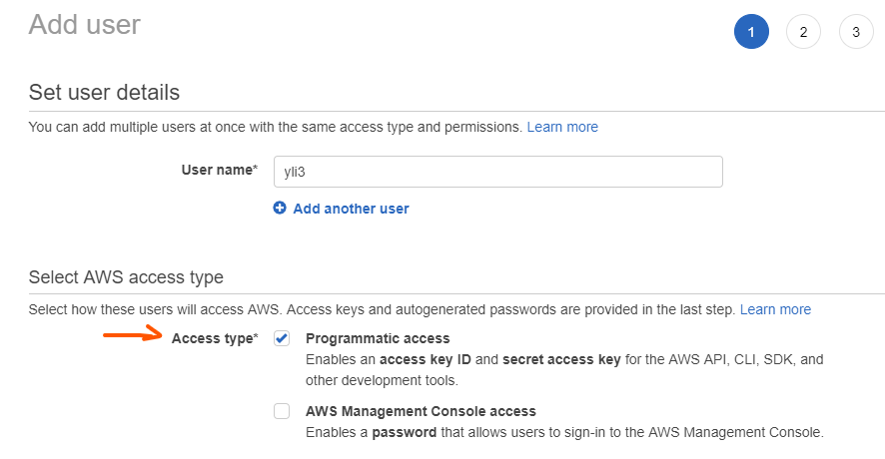

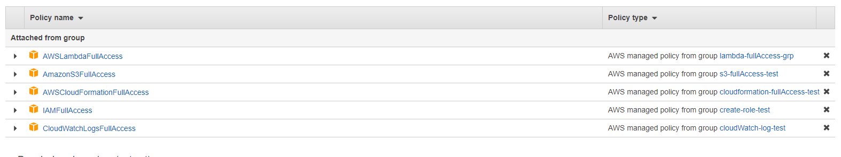

1. Create a group for S3

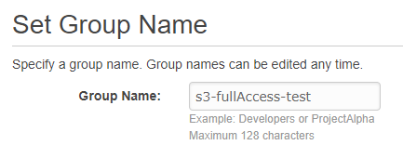

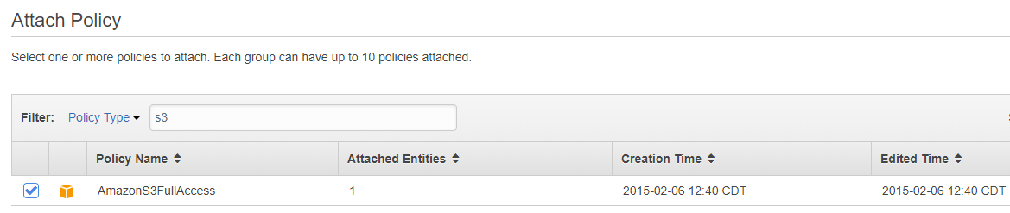

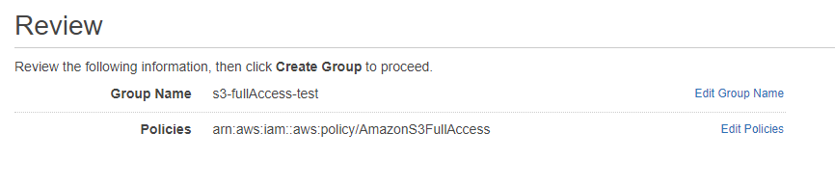

4. Create a new group for lambda

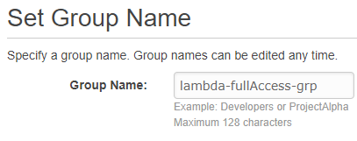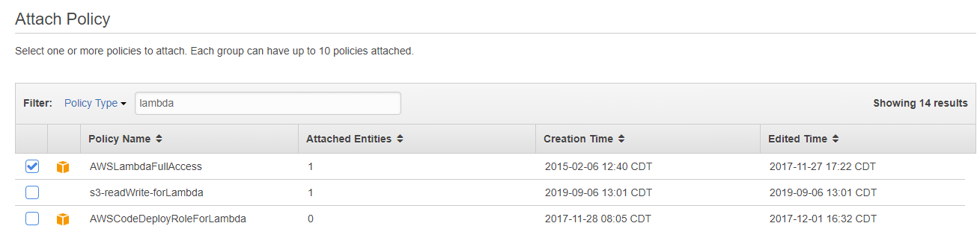



5-1. Create a new group for cloudformation

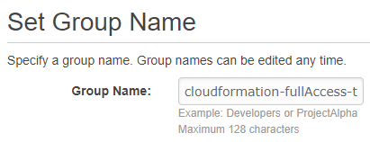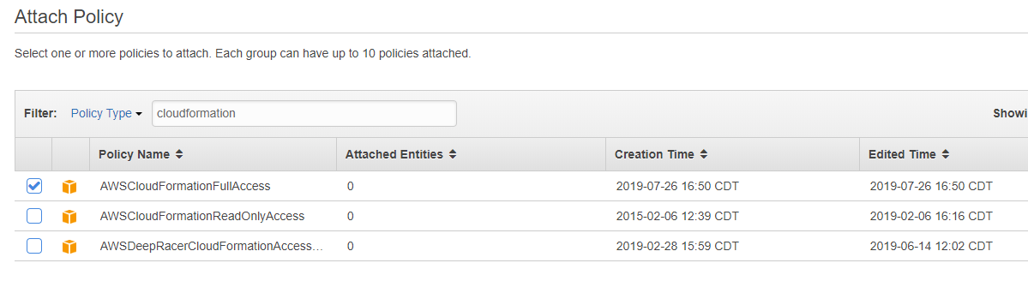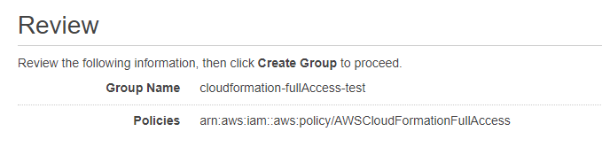

5-2, create role

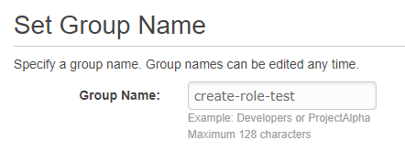

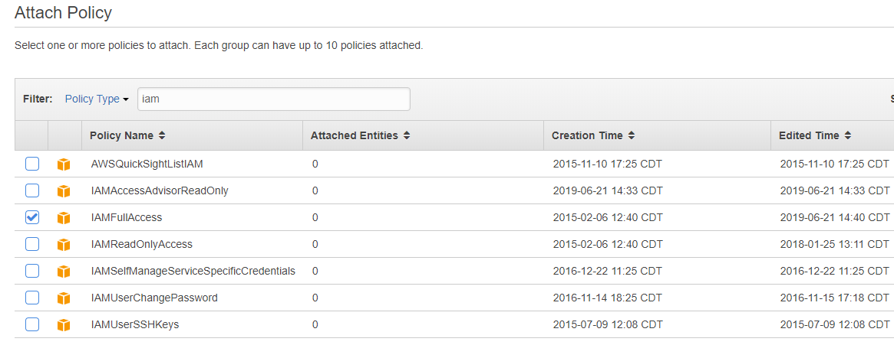

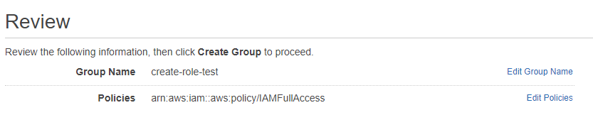

6. Create a developer user and add those three groups into the user





9. Testing the deployment

(base) D:\Project\AWS\Lambda\l7>sls deploy -v

Serverless: Generated requirements from D:\Project\AWS\Lambda\l7\requirements.txt in D:\Project\AWS\Lambda\l7\.serverless\requirements.txt...

Serverless: Using static cache of requirements found at C:\Users\yli\AppData\Local\UnitedIncome\serverless-python-requirements\Cache\5ebc7ddfa10ff584cd21e117fb08802d88430a5e4732a13c47b6b1b18a43c3b6_slspyc ...

Serverless: Packaging service...

Serverless: Excluding development dependencies...

Serverless: Injecting required Python packages to package...

Serverless: Installing dependencies for custom CloudFormation resources...

Serverless: Creating Stack...

Serverless: Checking Stack create progress...

CloudFormation - CREATE_IN_PROGRESS - AWS::CloudFormation::Stack - python-s3-aug29-dev

CloudFormation - CREATE_IN_PROGRESS - AWS::S3::Bucket - ServerlessDeploymentBucket

CloudFormation - CREATE_IN_PROGRESS - AWS::S3::Bucket - ServerlessDeploymentBucket

CloudFormation - CREATE_COMPLETE - AWS::S3::Bucket - ServerlessDeploymentBucket

CloudFormation - CREATE_COMPLETE - AWS::CloudFormation::Stack - python-s3-aug29-dev

Serverless: Stack create finished...

Serverless: Uploading CloudFormation file to S3...

Serverless: Uploading artifacts...

Serverless: Uploading service python-s3-aug29.zip file to S3 (4.66 MB)...

Serverless: Uploading custom CloudFormation resources...

Serverless: Validating template...

Serverless: Updating Stack...

Serverless: Checking Stack update progress...

CloudFormation - UPDATE_IN_PROGRESS - AWS::CloudFormation::Stack - python-s3-aug29-dev

CloudFormation - CREATE_IN_PROGRESS - AWS::IAM::Role - IamRoleCustomResourcesLambdaExecution

CloudFormation - CREATE_IN_PROGRESS - AWS::IAM::Role - IamRoleLambdaExecution

CloudFormation - CREATE_IN_PROGRESS - AWS::Logs::LogGroup - S3Dashf1LogGroup

CloudFormation - CREATE_IN_PROGRESS - AWS::IAM::Role - IamRoleCustomResourcesLambdaExecution

CloudFormation - CREATE_IN_PROGRESS - AWS::Logs::LogGroup - S3Dashf1LogGroup

CloudFormation - CREATE_COMPLETE - AWS::Logs::LogGroup - S3Dashf1LogGroup

CloudFormation - CREATE_IN_PROGRESS - AWS::IAM::Role - IamRoleLambdaExecution

CloudFormation - CREATE_COMPLETE - AWS::IAM::Role - IamRoleCustomResourcesLambdaExecution

CloudFormation - CREATE_COMPLETE - AWS::IAM::Role - IamRoleLambdaExecution

CloudFormation - CREATE_IN_PROGRESS - AWS::Lambda::Function - CustomDashresourceDashexistingDashs3LambdaFunction

CloudFormation - CREATE_IN_PROGRESS - AWS::Lambda::Function - S3Dashf1LambdaFunction

CloudFormation - CREATE_IN_PROGRESS - AWS::Lambda::Function - S3Dashf1LambdaFunction

CloudFormation - CREATE_IN_PROGRESS - AWS::Lambda::Function - CustomDashresourceDashexistingDashs3LambdaFunction

CloudFormation - CREATE_COMPLETE - AWS::Lambda::Function - S3Dashf1LambdaFunction

CloudFormation - CREATE_COMPLETE - AWS::Lambda::Function - CustomDashresourceDashexistingDashs3LambdaFunction

CloudFormation - CREATE_IN_PROGRESS - AWS::Lambda::Version - S3Dashf1LambdaVersionGdxJbJk961cIimwtomSZfNVQrct91ztU92EXH9LKM

CloudFormation - CREATE_IN_PROGRESS - Custom::S3 - S3Dashf1CustomS31

CloudFormation - CREATE_IN_PROGRESS - AWS::Lambda::Version - S3Dashf1LambdaVersionGdxJbJk961cIimwtomSZfNVQrct91ztU92EXH9LKM

CloudFormation - CREATE_COMPLETE - AWS::Lambda::Version - S3Dashf1LambdaVersionGdxJbJk961cIimwtomSZfNVQrct91ztU92EXH9LKM

CloudFormation - CREATE_IN_PROGRESS - Custom::S3 - S3Dashf1CustomS31

CloudFormation - CREATE_COMPLETE - Custom::S3 - S3Dashf1CustomS31

CloudFormation - UPDATE_COMPLETE_CLEANUP_IN_PROGRESS - AWS::CloudFormation::Stack - python-s3-aug29-dev

CloudFormation - UPDATE_COMPLETE - AWS::CloudFormation::Stack - python-s3-aug29-dev

Serverless: Stack update finished...

Service Information

service: python-s3-aug29

stage: dev

region: us-east-2

stack: python-s3-aug29-dev

resources: 8

api keys:

None

endpoints:

None

functions:

s3-f1: python-s3-aug29-dev-s3-f1

layers:

None

Stack Outputs

S3Dashf1LambdaFunctionQualifiedArn: arn:aws:lambda:us-east-2:341184398310:function:python-s3-aug29-dev-s3-f1:6

ServerlessDeploymentBucketName: python-s3-aug29-dev-serverlessdeploymentbucket-1sk6d53qbbun6

Serverless: Run the "serverless" command to setup monitoring, troubleshooting and testing.

10,check the log

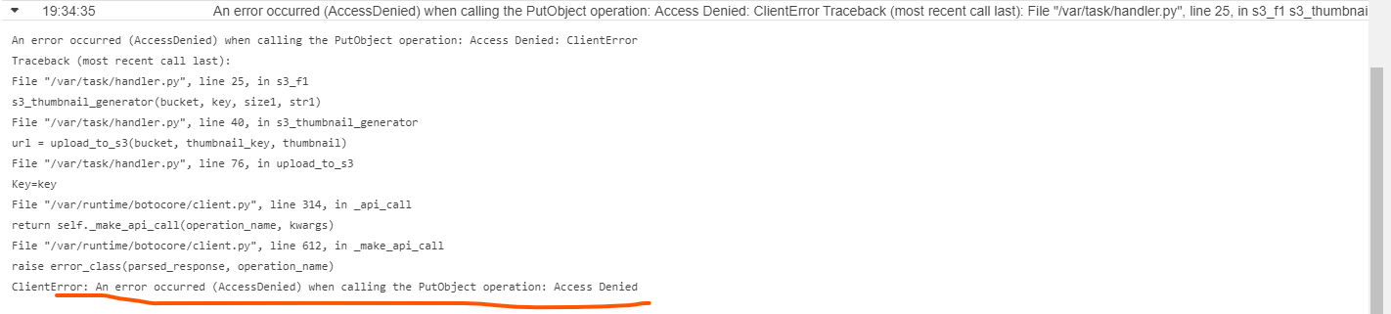

Just turn on S3 to public access, then error is gone

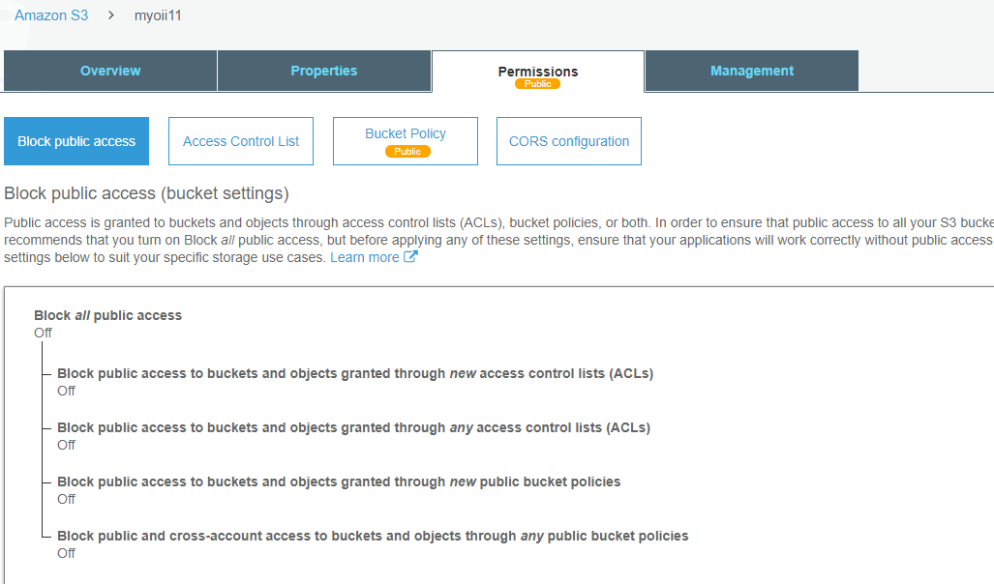

Verify it in output

